DIS-AM,C-Taino Collection-Final

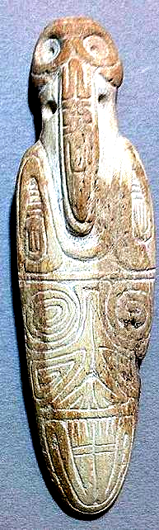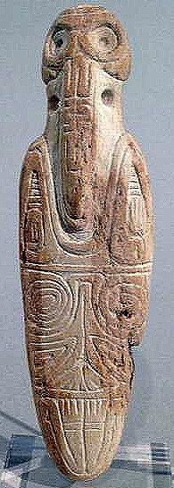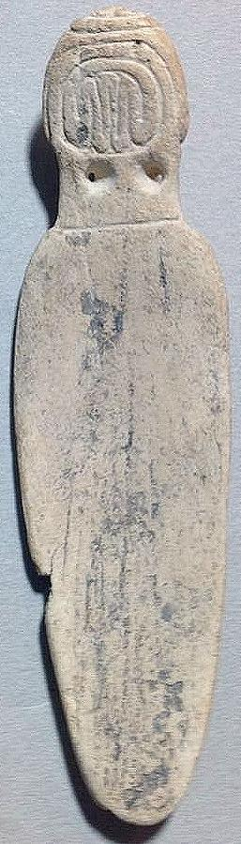INCLUDEPICTURE "../../Application%20Data/Microsoft/Local%20Settings/Temp/scl12.jpg" \* MERGEFORMATINET 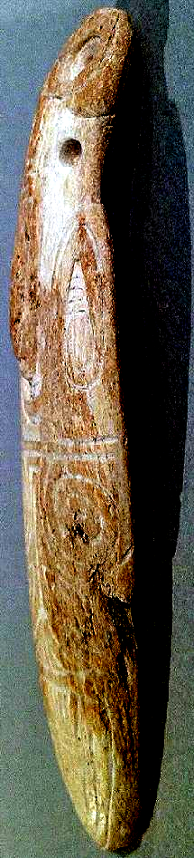

Long slender bird-human transformation figure. Arms curl up on either side of beak. Legs at bottom. Made of manatee rib and may be the distal end of a well used purging stick. Some natural wear to mid-right side. Front fully engraved. Length 10.2 cm. or 4in. Originally from the Dominican Republic and dateing ca. 1000-1500 AD.

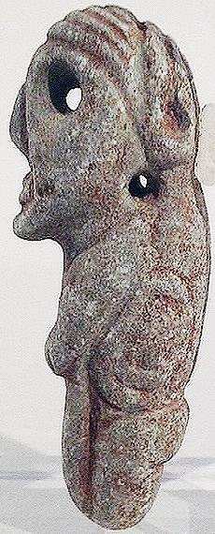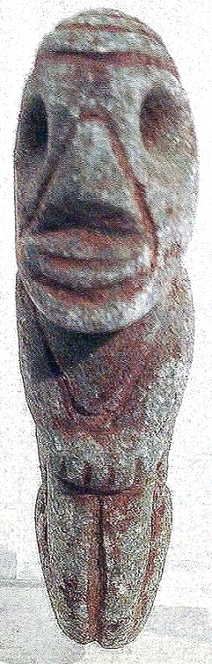 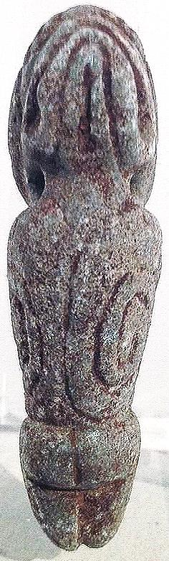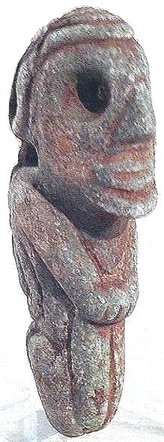 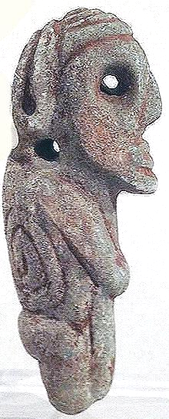

Small andesite pendant with pierced eyes. Likely an ancestor figure, headband at top of head. Portrayed with feet being held on front, odd. Back of pendant has to large swirls on each side. Originally from the Antilles, no island provenience, but likely the DR or PR. Length 5.4 cm . or 2.1 in. Dating 1000-1500 AD.

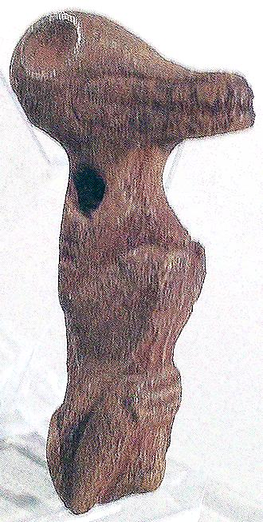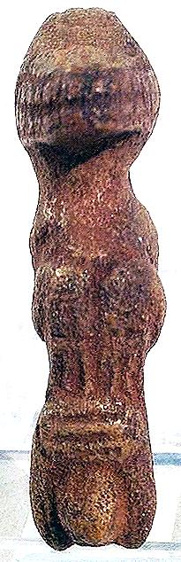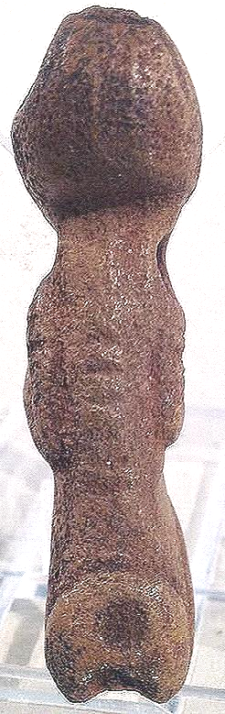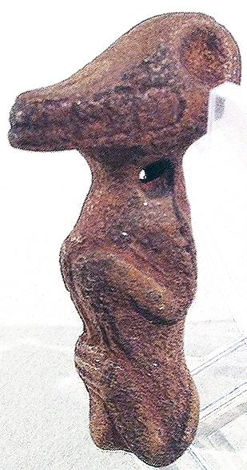

Hands on stomach and birthing bulge suggestsa fertility goddess, likely Atabey, who took on many animal personae. Arms and legs suggest anthropomorphic vestiges. Made of a dark brown hard lava stone. Originally from Hispaniola. Dating ca. 1000-1500 AD. Length 5.3 cm. or 2.1 in.

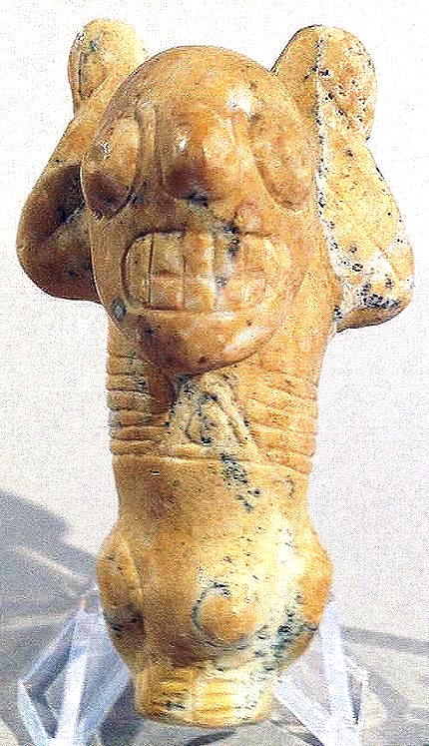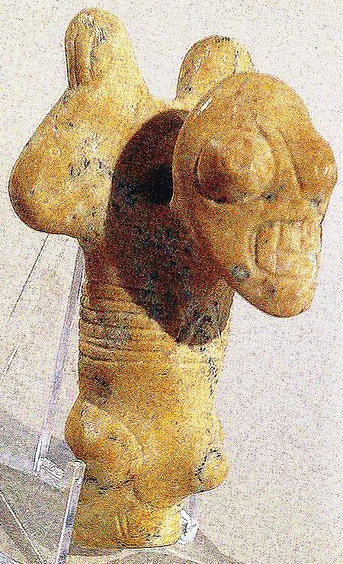 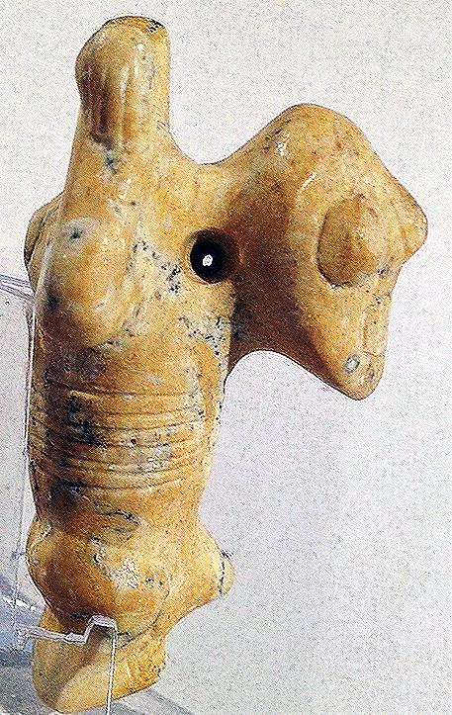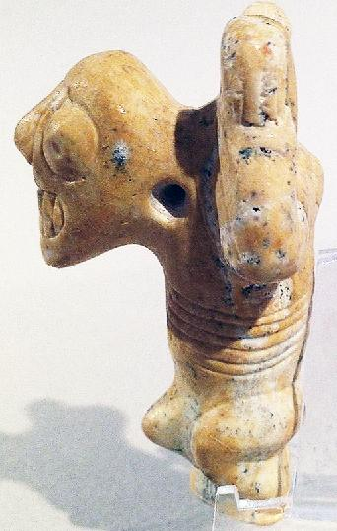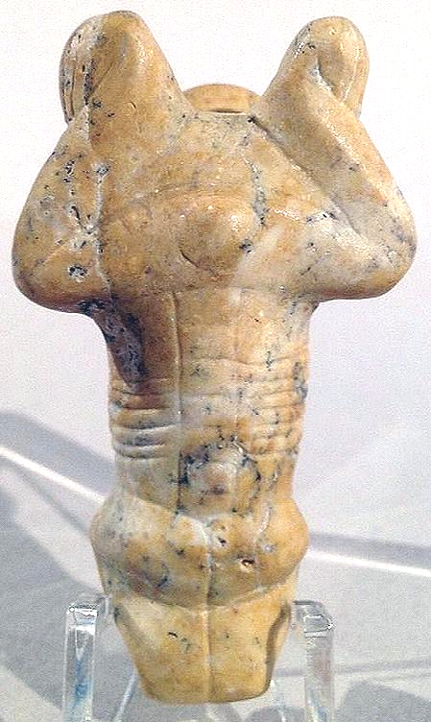

This is a nicely conceived piece with nice tan jasper color, and scattered patches of black specks. Typical Atabey markers...arms up, grimacing mouth, birthing bulge. Reverse, characterized frog shaped, frog with birthing bulge as well. Here you have twin references to fertility...Atabey was called frog-mother because of the frogs connection to spring, water, and abundant eggs. Length 6.2cm or 2.4"  
Originally from the Dominican Republic Dating ca. 1000-1500 AD.

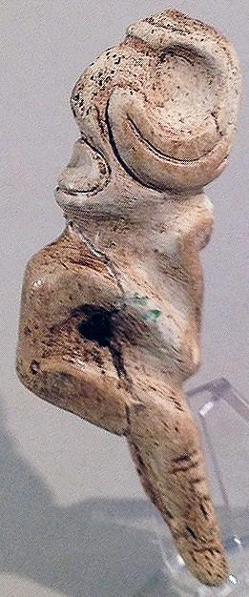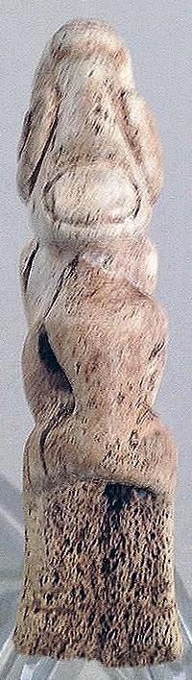 SHAPE \* MERGEFORMAT 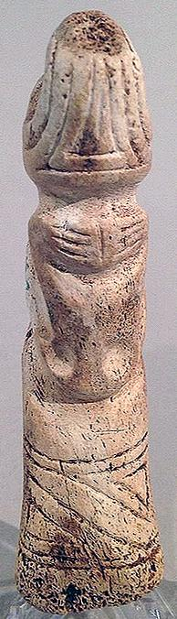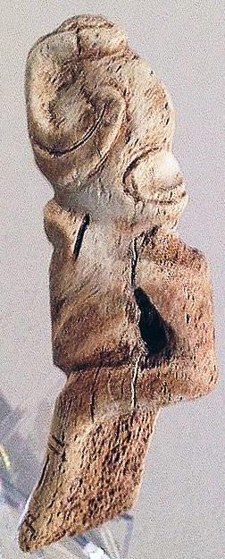

This piece is made from manatee bone and resembles a well worn spoon with an anthropomorphic figure carved on top. On the reverse another face can be seen by turning *cemi* upside down. Natural bone stress lines under chin but may have been broken and reattached, hard to tell, no glue residue. Length 8.8 cm. or 3.4 in. Originally from Hispaniola, dating ca. 1000-1500 AD.

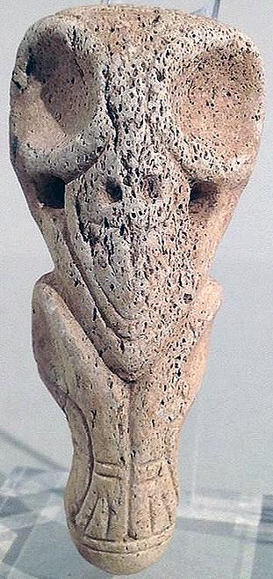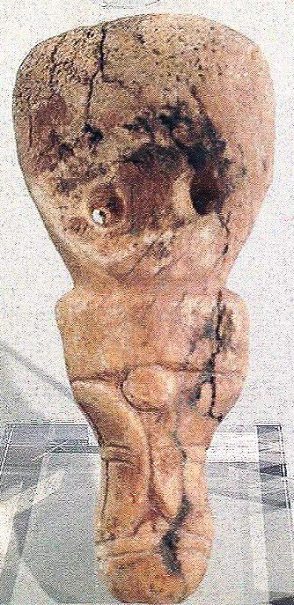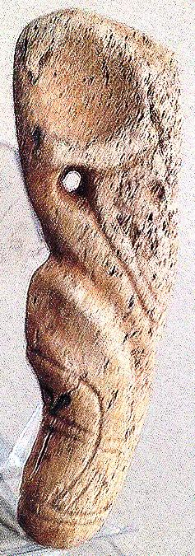

Made of manatee bone this pendant has long anthropomorphic legs and an extra large head. Base is rounded so possibly used as small pestle. Length 6.4 cm. or 2.5 in. Originally from Hispaniola and dating ca.1000-1500 AD.

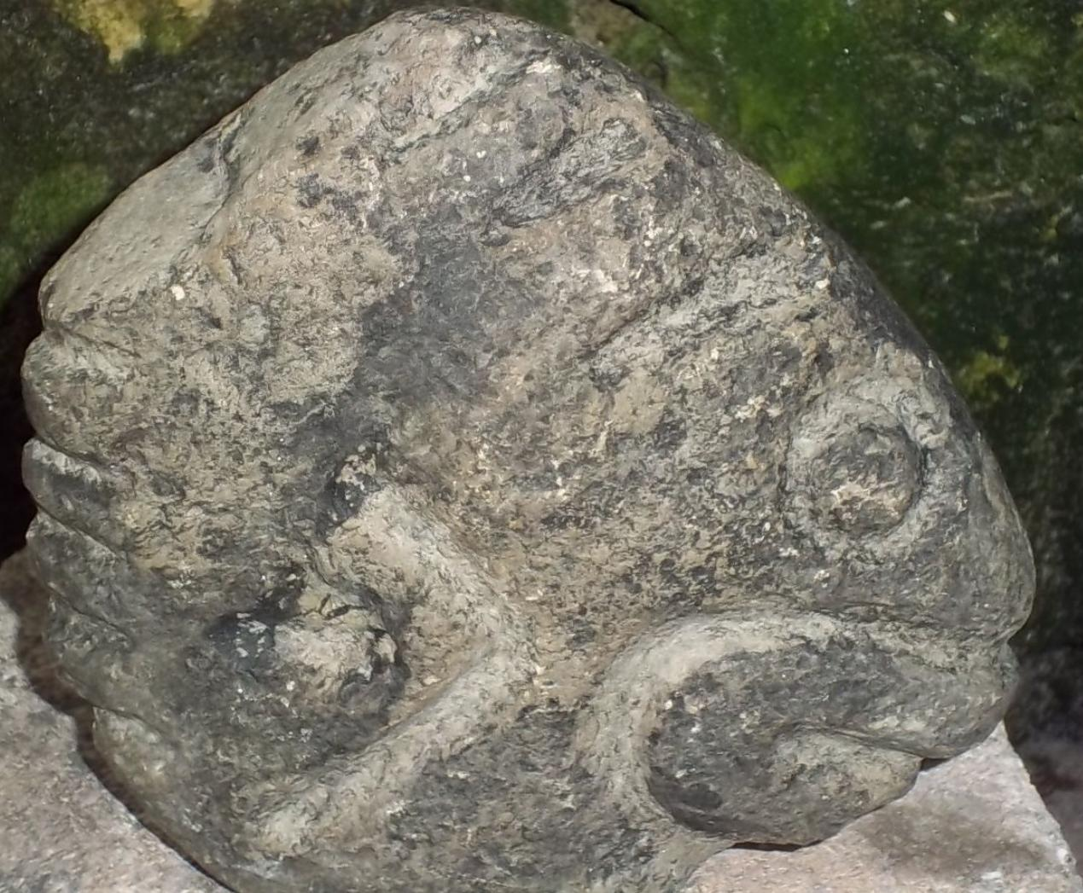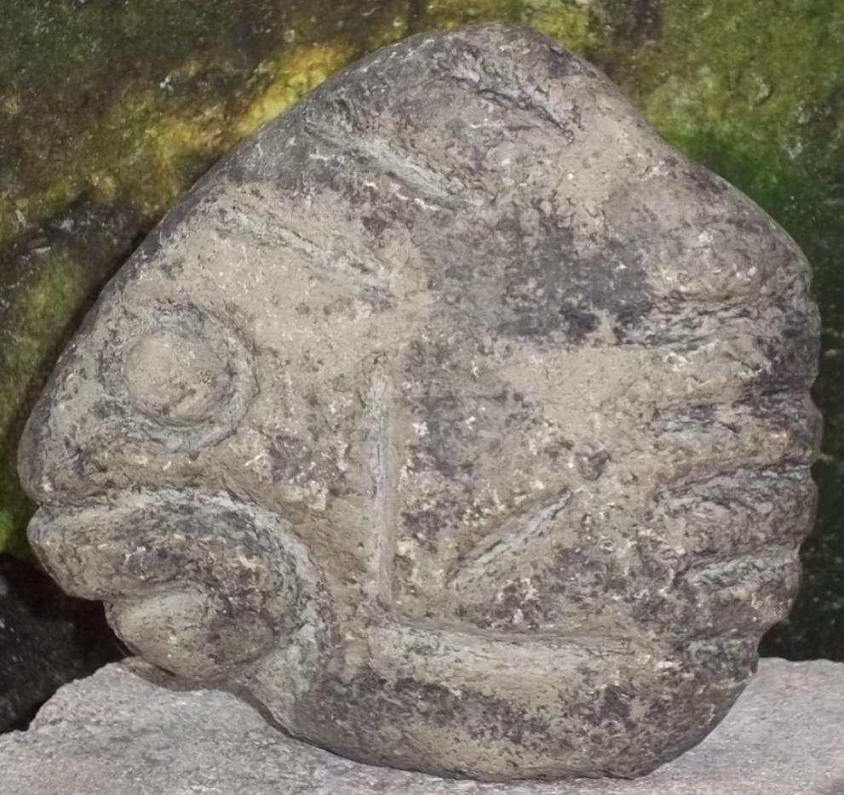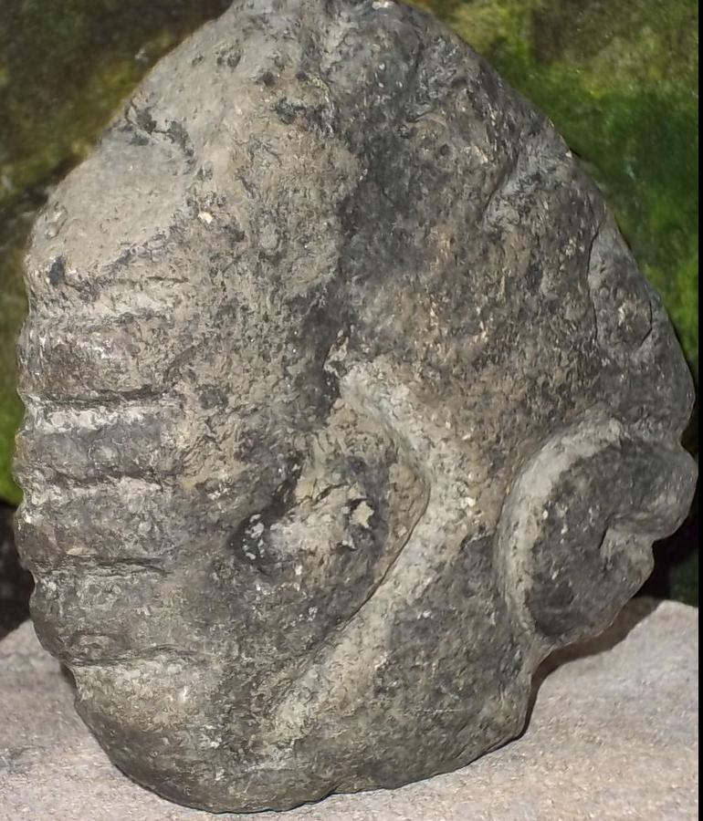

This is a stone Cemi figure representing a fish, it was brought back from the Dominican Republic in the 1960'sThe size is approximately 5 1/2 in. x 5 3/8 in. x 1 1/24 in.T he weight is almost 2 pounds six oz .

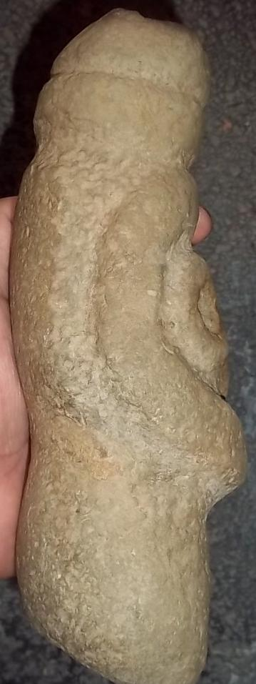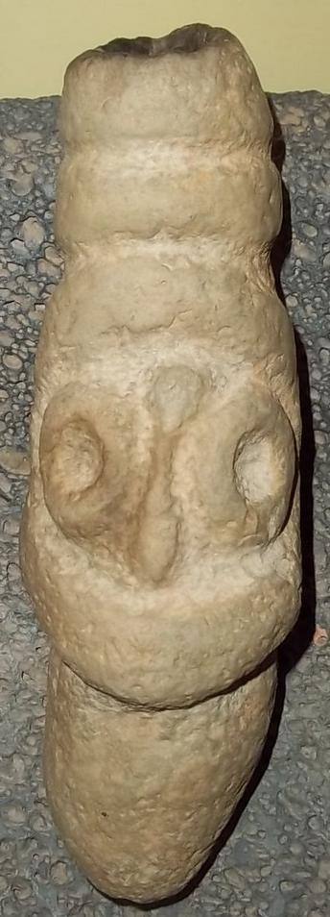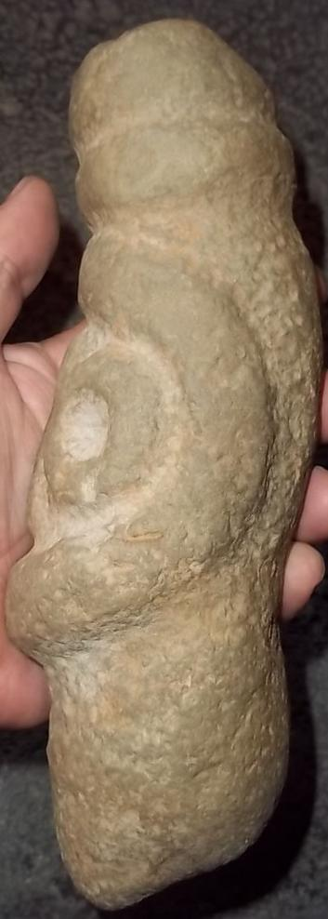

Stone Cemi figure that appears to be a torch. It was brought back from the Dominican Republic in the 1960's. The cemi stone has a depression on the top which has burn marks, and the other end has a depression and fain traces of burn marks. In the Taino cosmology the upright torch would have been used for earthly ceremonies while the torch held upside-down would have been used in underworld ceremonies as the holder of the torch entered a cave sanctuary. The size is approximately 10 in. x 5 1/4 in.x 3 1/2 in. The weight is almost six pounds.

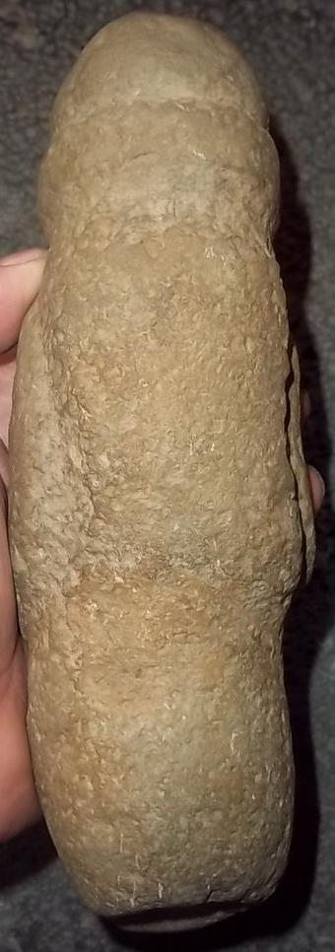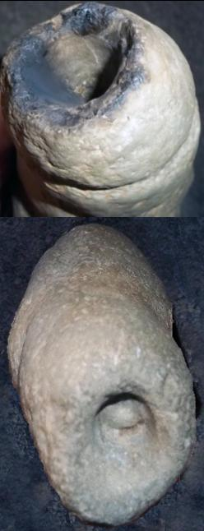

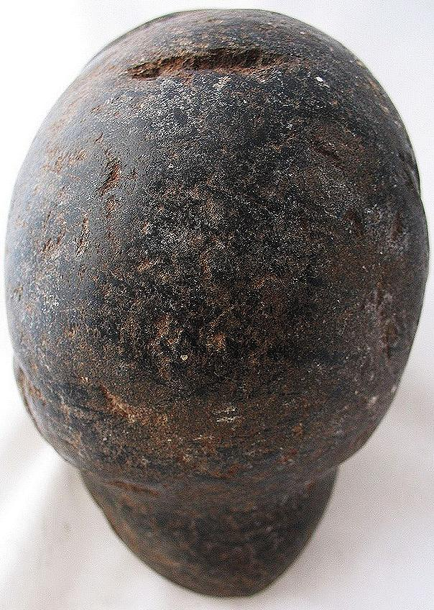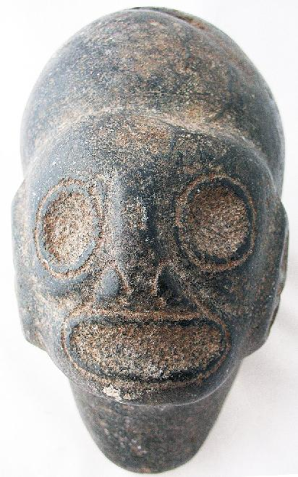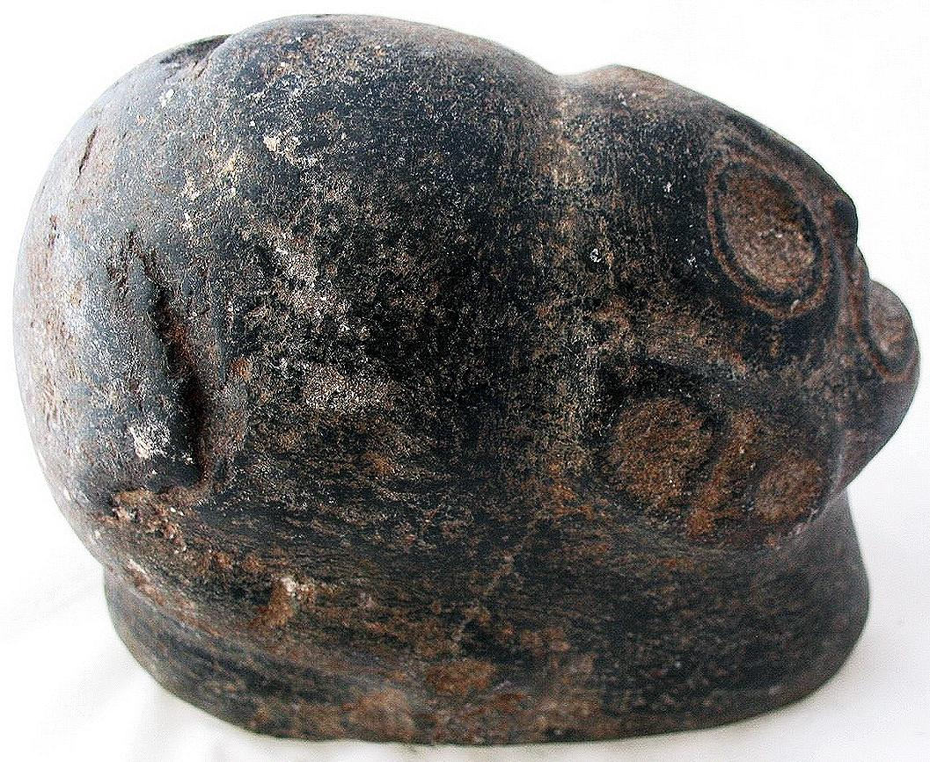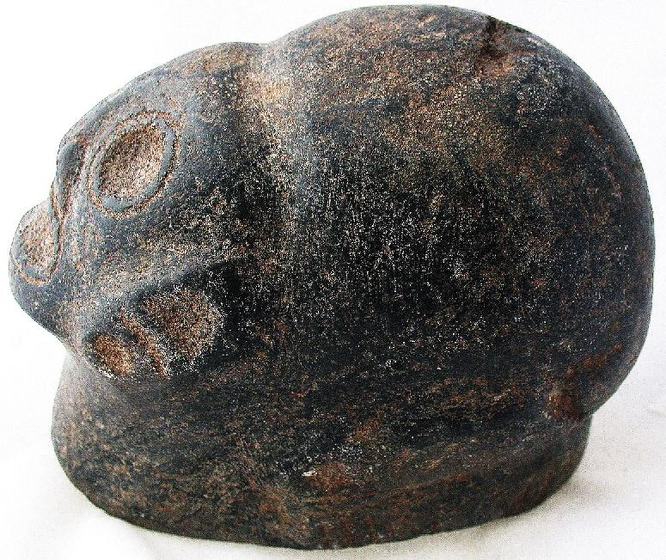

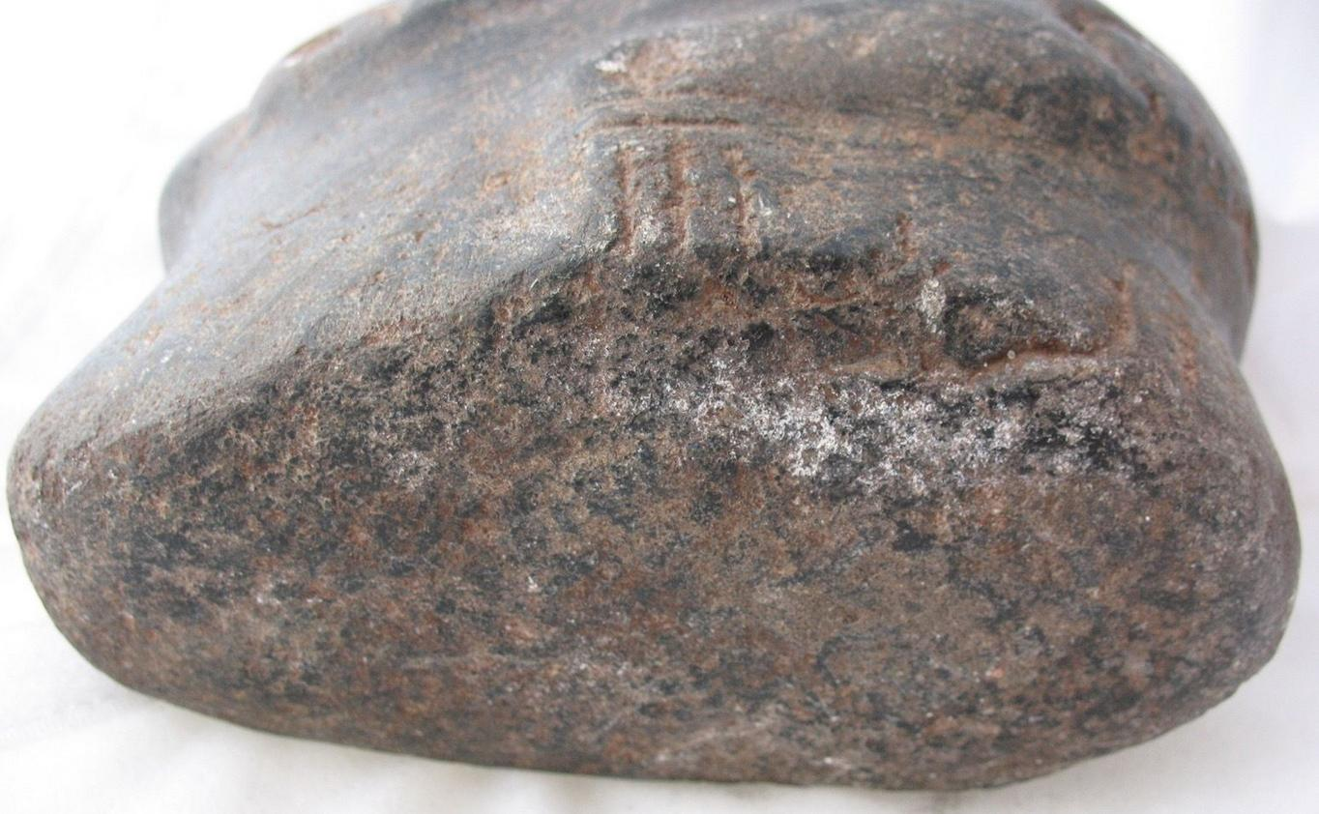

5 pounds and 8 ounces. It is approx. 6” long and approx. 4 and 3/4” tall and approx. 3.5” wide.

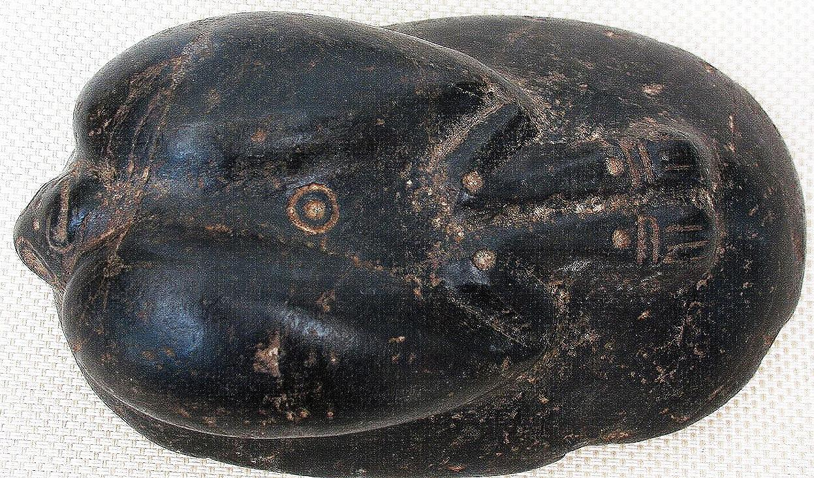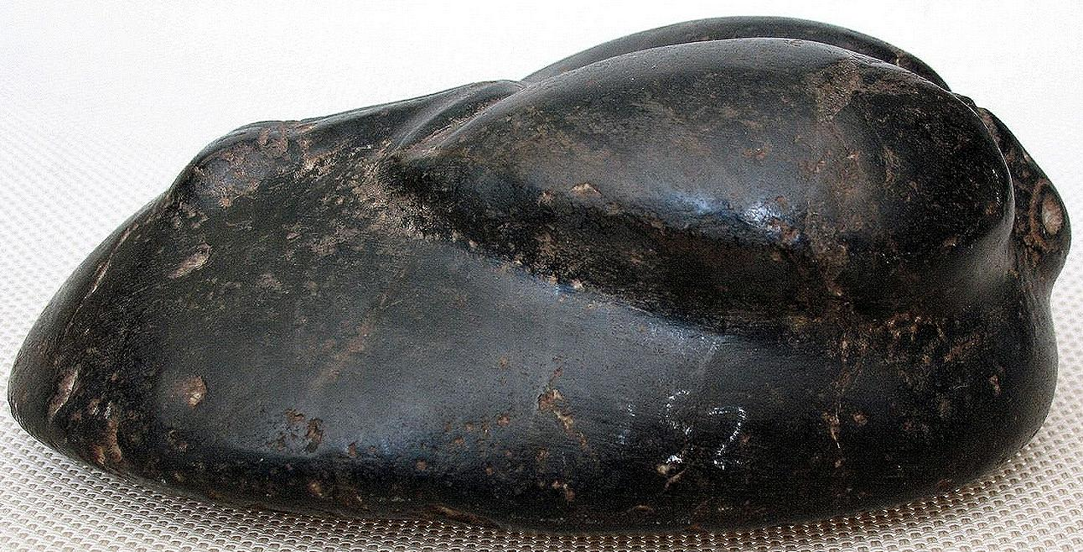

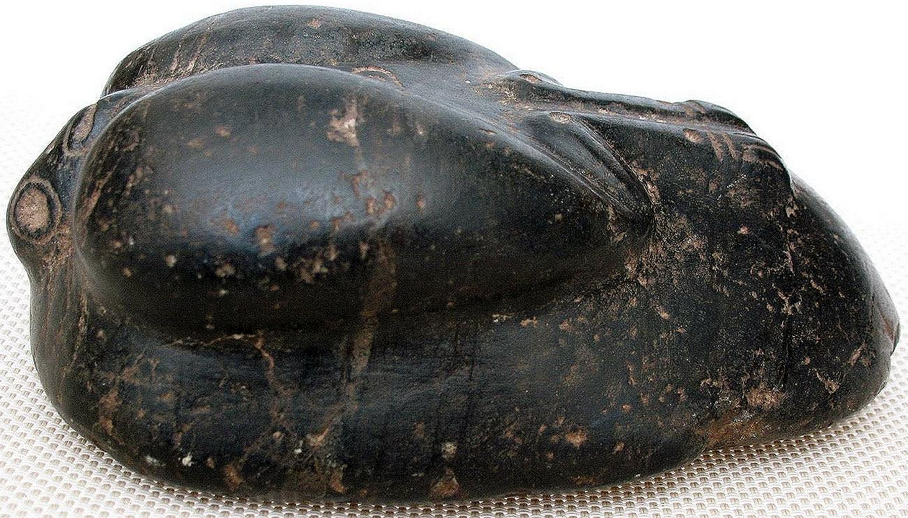

# Taino carved polished stone Zemi frigate bird marker Hispaniola

4 pounds and 4.8 ounces. It is approx. 6.75” long and approx. 3” tall and approx. 4” wide.

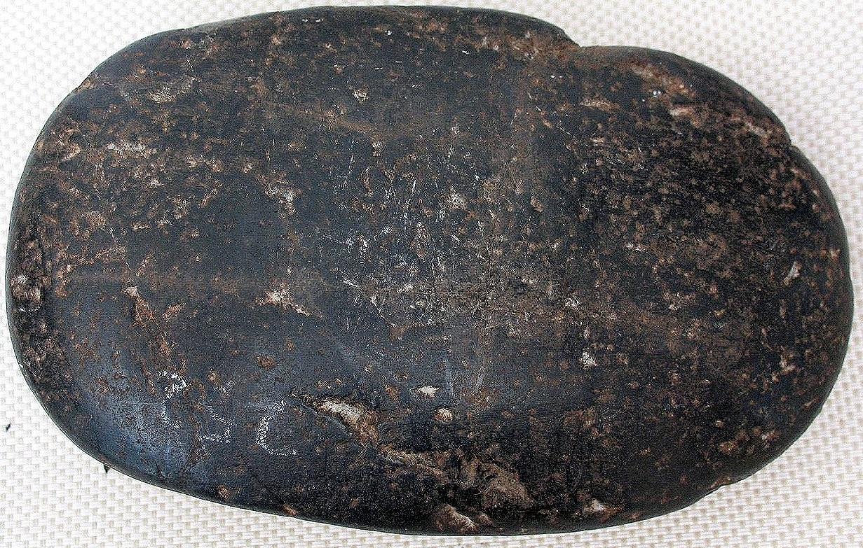

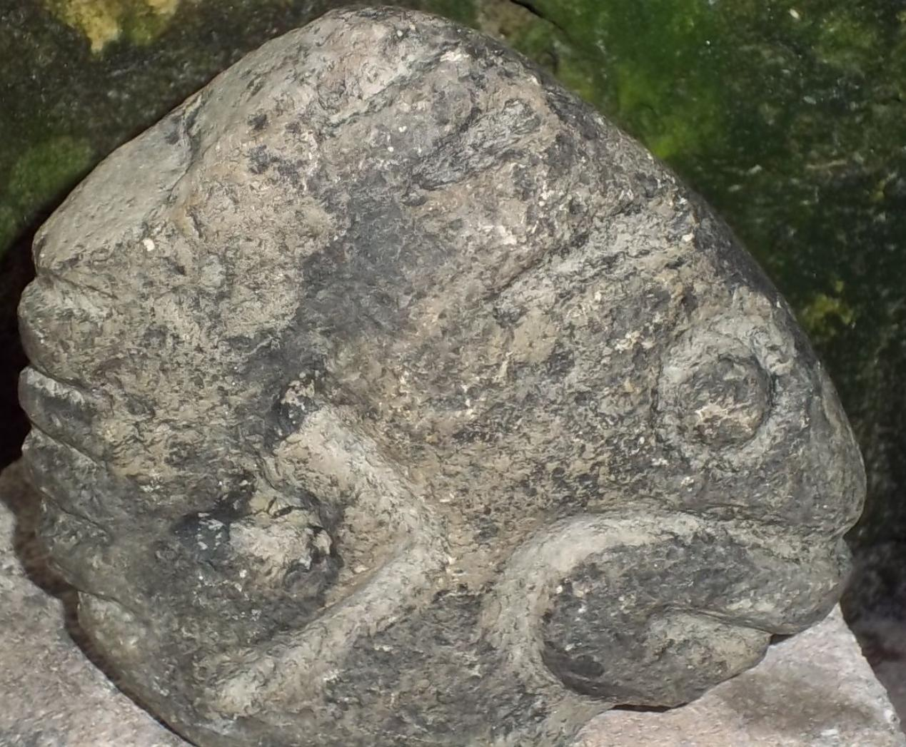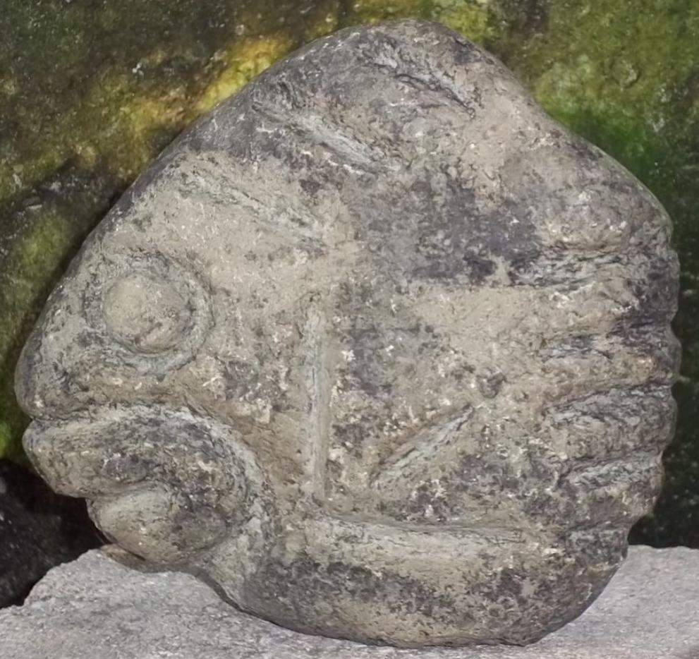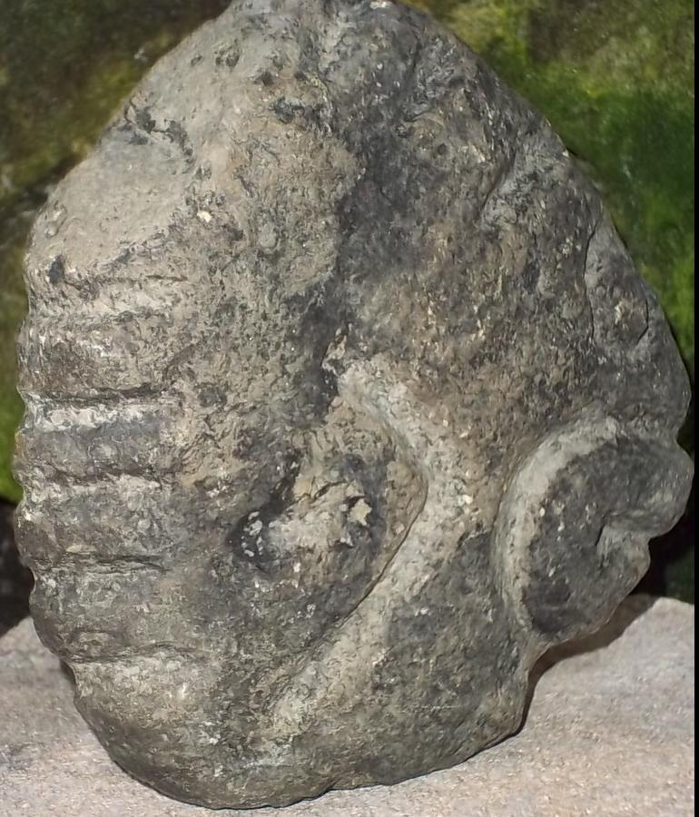

This is a stone Cemi figure representing a fish, it was brought back from the Dominican Republic in the 1960's.  I do not know the age of the piece, it appears to be old, I know that their origin was the Dominican Republic.   The Domnican Republic was at the heart of the Taino empire from about 1100-1492 and is where Columbus landed and encountered the Taino culture.  The size is approximately 5 1/2" x 5 3/8" x 1 1/24  The weight is almost 2 pounds six oz .

EBAY-2015-3 Oct

Sold by [flapast](http://myworld.ebay.com/flapast) ( [13157](http://feedback.ebay.com/ws/eBayISAPI.dll?ViewFeedback&userid=flapast) )

### Delivery package 1 of 1

Estimated delivery Saturday, Oct 10, 2015

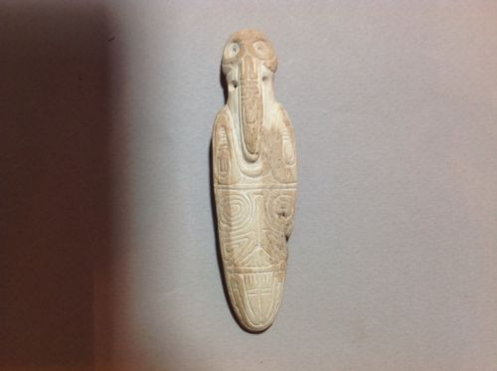

#### [Taino Pendant Big Beak Bird Anthropic Transformation, PreColumbian](http://www.ebay.com/itm/252104537111)

|  |  |
| --- | --- |
| Item price | $142.50 |
| Quantity | 1 |
| Item number | 252104537111 |
| Shipping service | USPS Priority Mail |

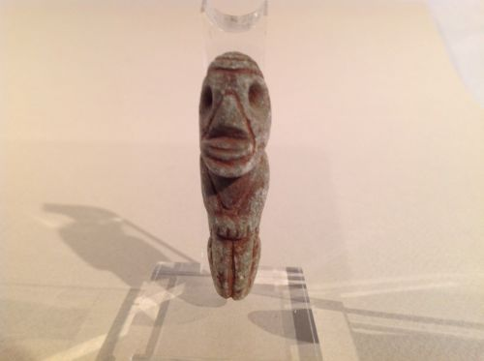

#### [Taino Andesite Anthropic Pendant, PreColumbian](http://www.ebay.com/itm/252104578401)

|  |  |
| --- | --- |
| Item price | $114.50 |
| Quantity | 1 |
| Item number | 252104578401 |
| Shipping service | USPS Priority Mail |

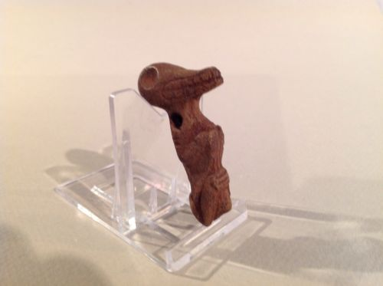

#### [Taino Stone Iguana Fertility Transformation. PreColumbian](http://www.ebay.com/itm/262066509087)

|  |  |
| --- | --- |
| Item price | $242.50 |
| Quantity | 1 |
| Item number | 262066509087 |
| Shipping service | USPS Priority Mail |

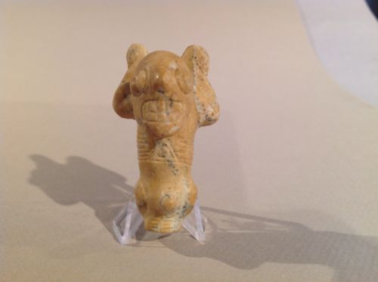

#### [Taino Jasper Pendant, Atabey, Goddess Of Fertility, PreColumbian](http://www.ebay.com/itm/262066625566)

|  |  |
| --- | --- |
| Item price | $162.50 |
| Quantity | 1 |
| Item number | 262066625566 |
| Shipping service | USPS Priority Mail |

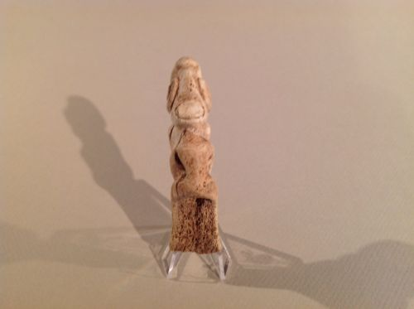

#### [Taino Anthropic Figure, Spoon? PreColumbian](http://www.ebay.com/itm/262066646218)

|  |  |
| --- | --- |
| Item price | $122.50 |
| Quantity | 1 |
| Item number | 262066646218 |
| Shipping service | USPS Priority Mail |

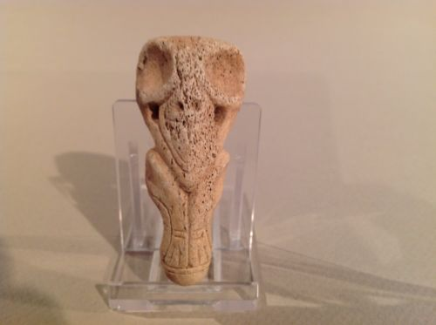

#### [Taino Bird-Human Transformation Pendant. PreColumbian](http://www.ebay.com/itm/262066766729)

|  |  |
| --- | --- |
| Item price | $124.72 |
| Quantity | 1 |
| Item number | 262066766729 |
| Shipping service | USPS Priority Mail |

Sold by [flapast](http://myworld.ebay.com/flapast) ( [13157](http://feedback.ebay.com/ws/eBayISAPI.dll?ViewFeedback&userid=flapast) )

### Delivery package 1 of 1

Estimated delivery Monday, Oct 12, 2015

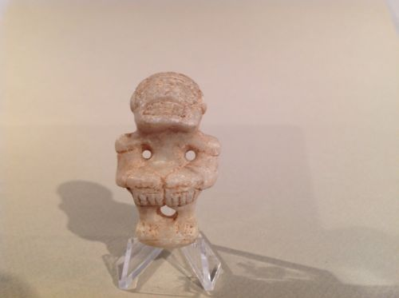

#### [Taino Marble Ancestor Or Cacique Pendant PreColumbian](http://www.ebay.com/itm/262066461342)

|  |  |
| --- | --- |
| Item price | $65.00 |
| Quantity | 1 |
| Item number | 262066461342 |
| Shipping service | Economy Shipping |

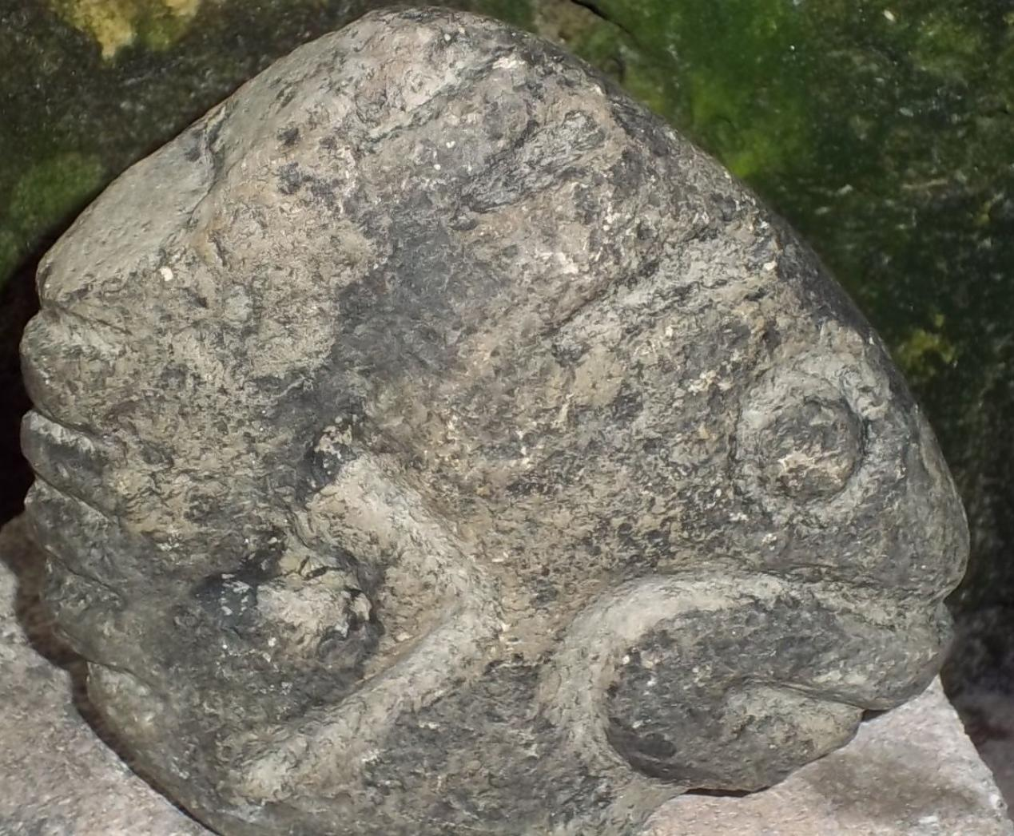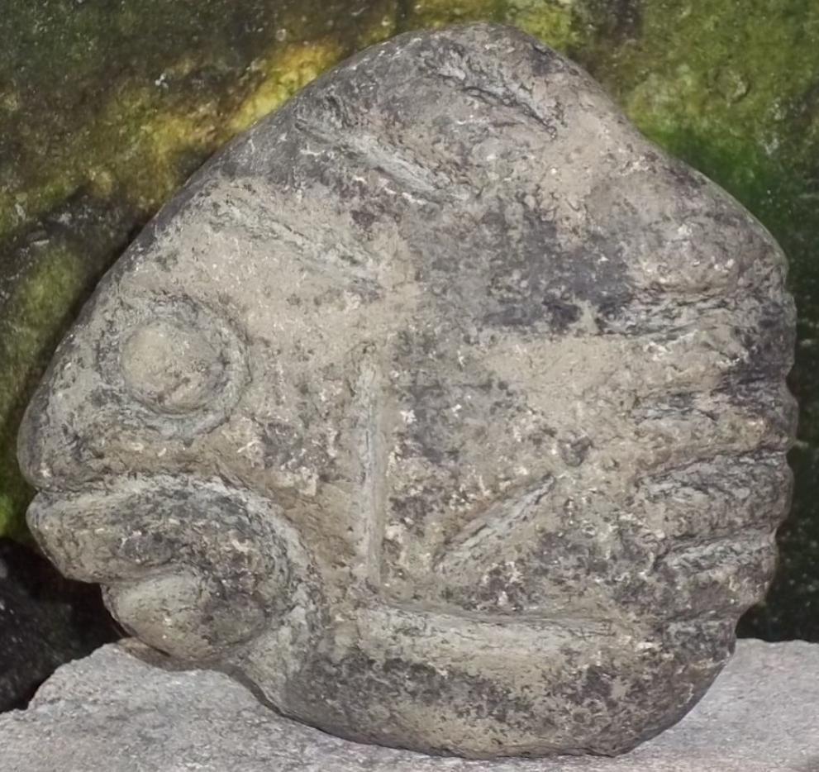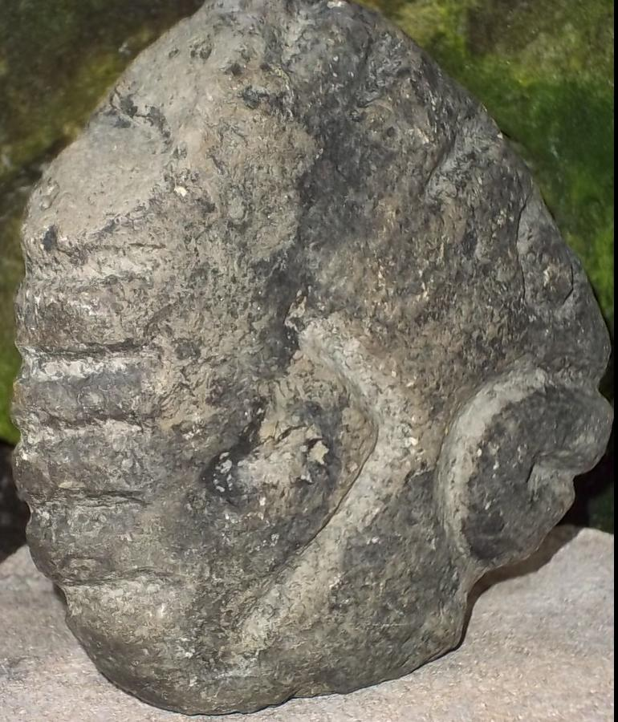

This is a stone Cemi figure representing a fish, it was brought back from the Dominican Republic in the 1960's.  I do not know the age of the piece, it appears to be old, I know that their origin was the Dominican Republic.   The Domnican Republic was at the heart of the Taino empire from about 1100-1492 and is where Columbus landed and encountered the Taino culture.  The size is approximately 5 1/2" x 5 3/8" x 1 1/24  The weight is almost 2 pounds six oz .